How to get access to internet on campuses……
- You need to open an internet account in the university IT center.
Get ready to open a campus internet account.
You need to prepare:
- Cash (￥60-150, depending on which kind of account you would like to open)
- Your ID card (or anything that shows you are a CAU student)
- A username for your internet account and email account (e.g. mike1234 and mike1234@cau.edu.cn)
- A password for your internet account and email account

Where:
Room 110, West campus main building (the one facing the main gate of the west campus)

You can fill in the following chart and show it to the staff working in the IT center since there is only Chinese language service available.

This is the account that I would like to open up.
请帮助我开一个网关账户，以下是我的选择。
权限  Limitation | 开户费  Charge for opening an account | 月租费  Fixed monthly charge | 流量费  Charge for current | 选择  Your choice
国内网  Webs within China | ￥50 yuan | ￥10 yuan | No charge
国际网  International webs | ￥50 yuan | ￥10 yuan | ￥30 yuan/8 hr
国际网  International webs | ￥50 yuan | ￥10 yuan | ￥50 yuan/60 hr
国际网  International webs | ￥50 yuan | ￥10 yuan | ￥90 yuan/1 month

- When you have the account, go to visit the CAU homepage at http://www.cau.edu.cn . Pictures shown as follow. Click on the link shown in the red box.
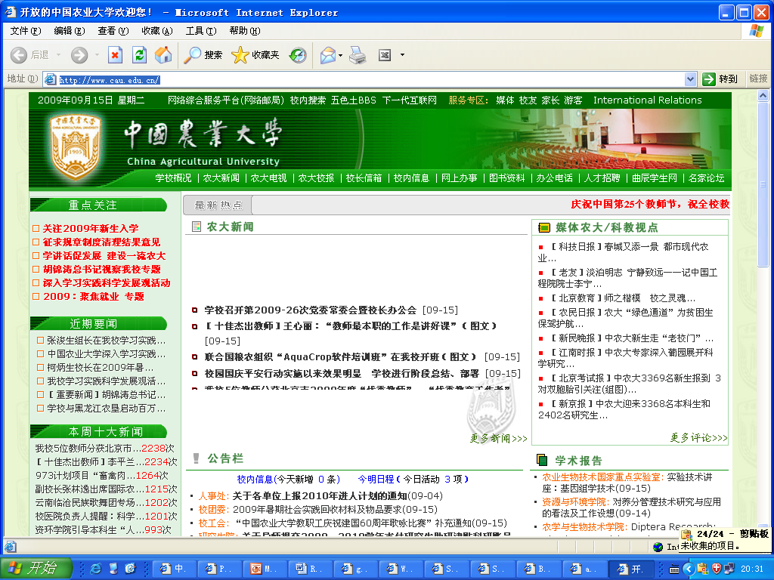

Then you will get to the following page (http://netcenter.cau.edu.cn/caunet_clt/). Fill in your username and password, then click on the connect button shown in the red box.
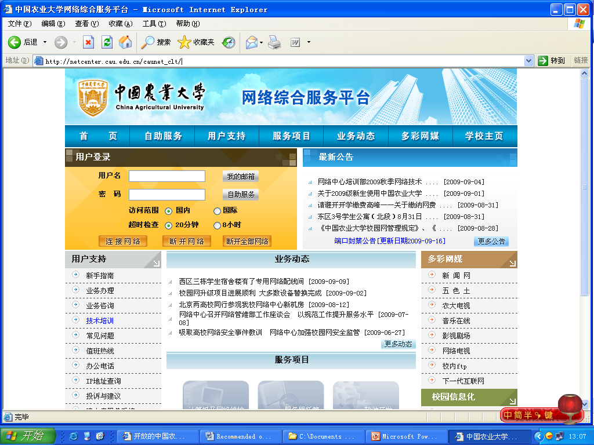
Username
Password

